Photo Specifications Sheet

Frame subject with full face, front view, eyes open
Make sure photo presents full head from top of hair to bottom of chin; height of head should measure 1 inch to 1-3/8 inches (25 mm to 35 mm)
Center head within frame (see Figure 2 below)
Make sure eye height is between 1-1/8 inches to 1-3/8 inches (28 mm and 35 mm) from bottom of photo
Photograph subject against a plain white or off-white background
Position subject and lighting so that there are no distracting shadows on the face or background
Encourage subject to have a natural expression

Proper Photos

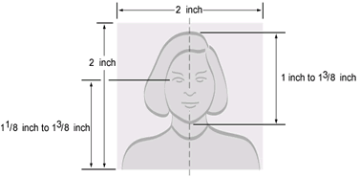

For more information please link to:
http://travel.state.gov/content/passports/english/passports/photos/photo-examples.html

